UCS301 Data Structures
Lab Assignment 1
(Week 1)
- Develop a Menu driven program to demonstrate the following operations of Arrays
——MENU——-
1. CREATE
2. DISPLAY
3. INSERT
4. DELETE
5. LINEAR SEARCH
6. EXIT

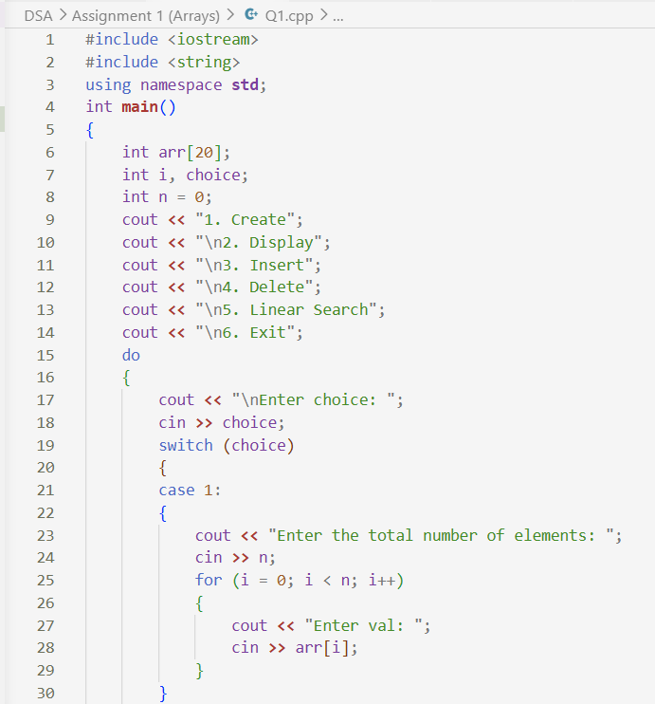

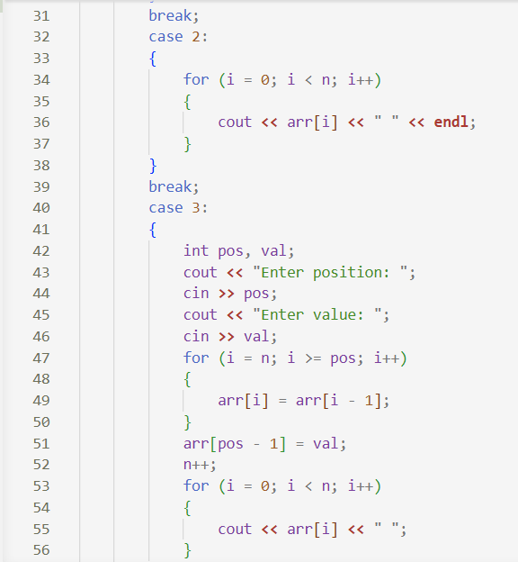

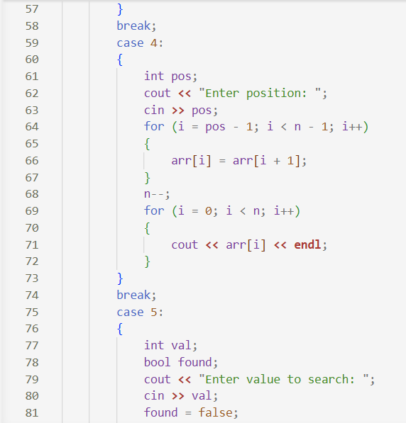

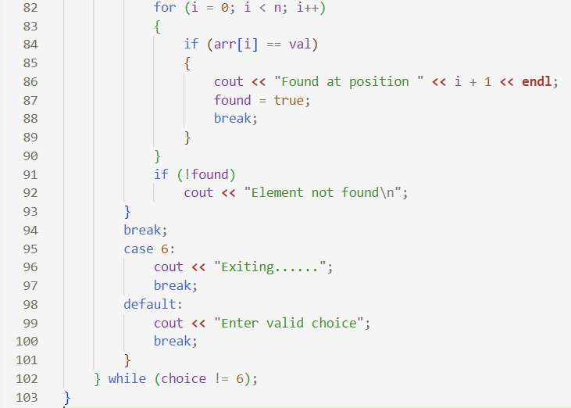

- Design the logic to remove the duplicate elements from an Array and after the deletion the array should contain the unique elements.

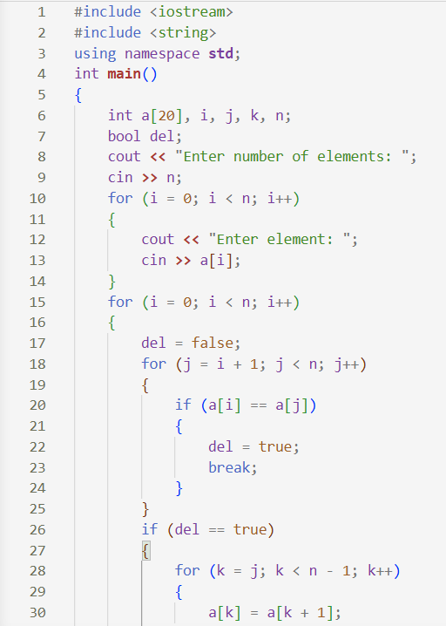

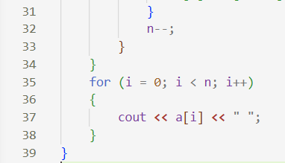

- Design the logic of a program to rotate a 1-D array by K positions. e.g., for A = {1,2,3,4,5} and K = 2, the left rotation is {3,4,5,1,2} and the right rotation is {4,5,1,2,3}.

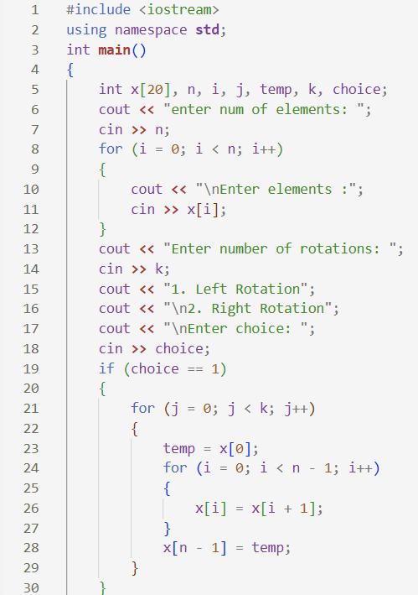

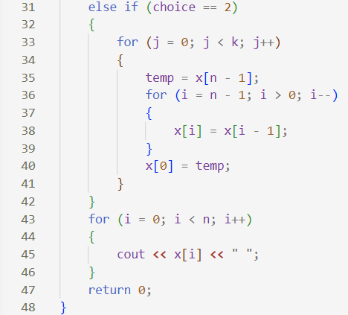

4) Implement the logic to
a. Reverse the elements of an array
b. Find the matrix multiplication
c. Find the Transpose of a Matrix

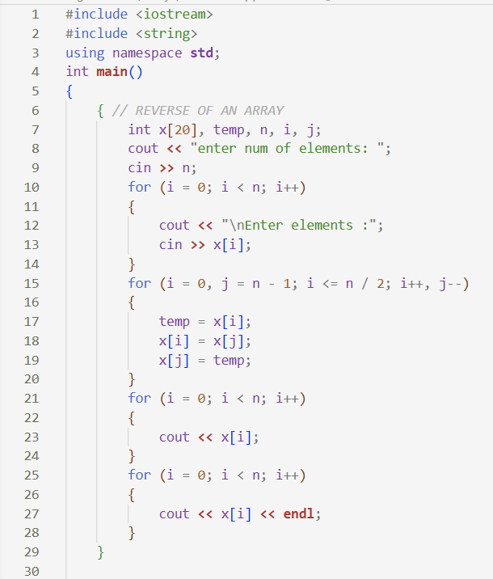

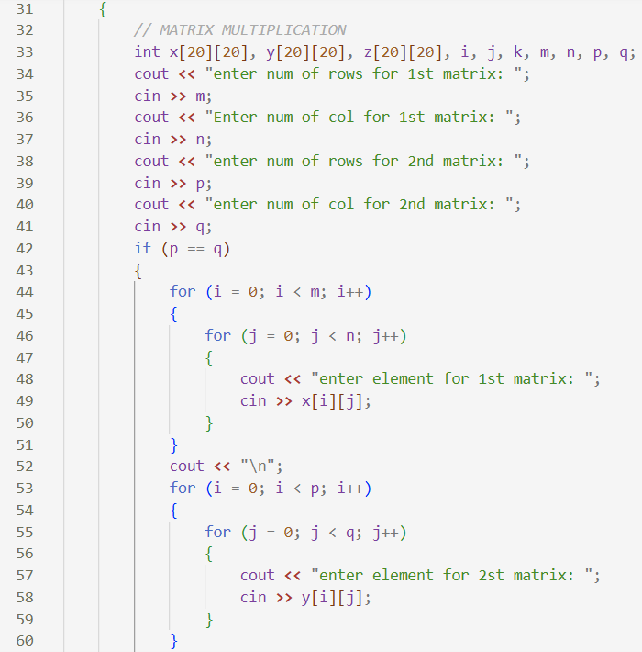
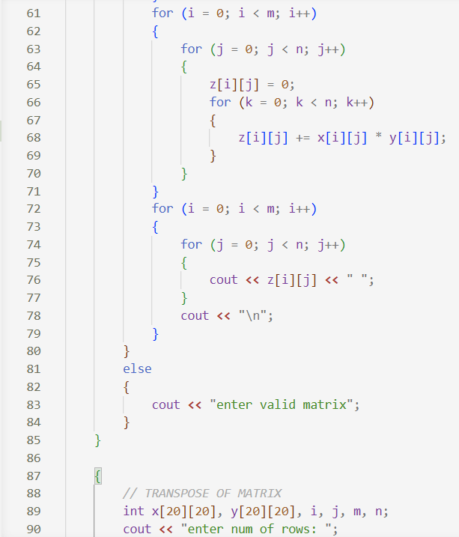
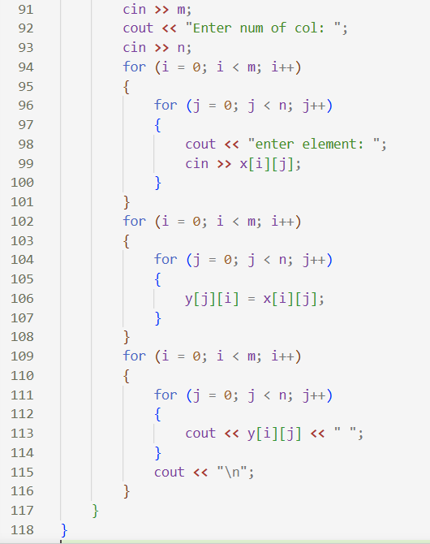
5) Write a program to find sum of every row and every column in a two-dimensional array.

